
AMERICAN INTERNATIONAL UNIVERSITY-BANGLADESH
Faculty of Science and Technology
Department of Computer Science
CSC 4118: Computer Graphics

Final Term Project Evaluation | Semester: Spring 2024-2025 |  | CO Assessed: CO3 |  |  | Total Marks:
Name |  | ID |  | Section: | SL. | Group No.
Fahim Hassan |  | ID: 23-55325-3 |  |  |  | 5
AIQUL ISLAM SAKIB |  | ID: 23-55255-3 |  |  |  | 5
MD. NAFIS-UL HOQUE BONDHON |  | ID: 23-55212-3 |  |  |  | 5
Fabiha Lamisa Tridha |  | ID: 23-54966-3 |  |  |  | 5
OBE Evaluation:
CO3: Integrate the development of visual and conceptual skills to design solutions through the process of idea development, refinement, and assessment in the creation of real-world projects.
Requirement specification (5) | Design & Implementation (5) | Total Marks (10)

City Of Disaster


AMERICAN INTERNATIONAL UNIVERSITY-BANGLADESH
Faculty of Science and Technology
Department of Computer Science
CSC 4118: Computer Graphics

Final Term Project Evaluation | Semester: Spring 2024-2025 |  | CO Assessed: CO3 |  |  | Total Marks:
Name: |  | ID: |  | Section: | SL. | Group No.
OBE Evaluation:
CO3: Integrate the development of visual and conceptual skills to design solutions through the process of idea development, refinement, and assessment in the creation of real-world projects.
Requirement specification (5) | Design & Implementation (5) | Total Marks (10)

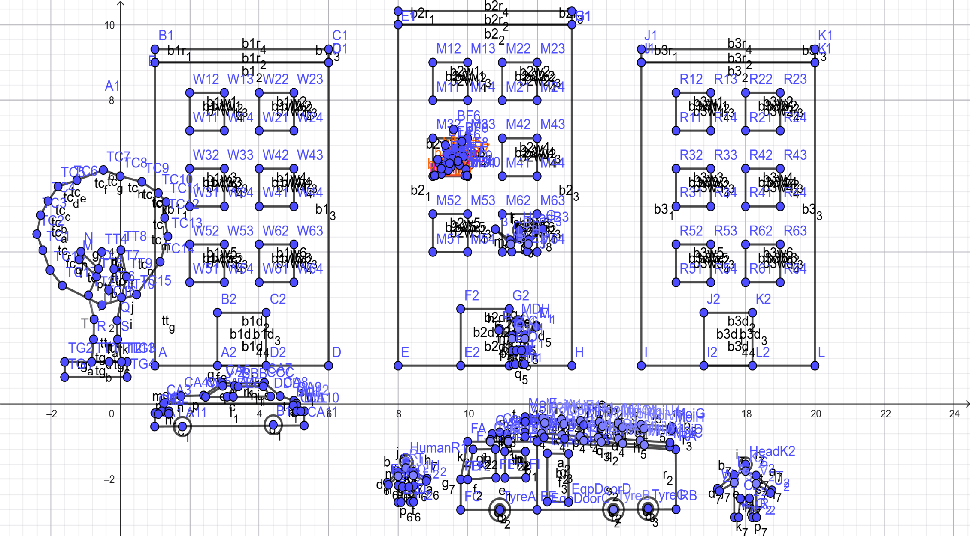
Fahim Hassan (ID:23-55325-3)
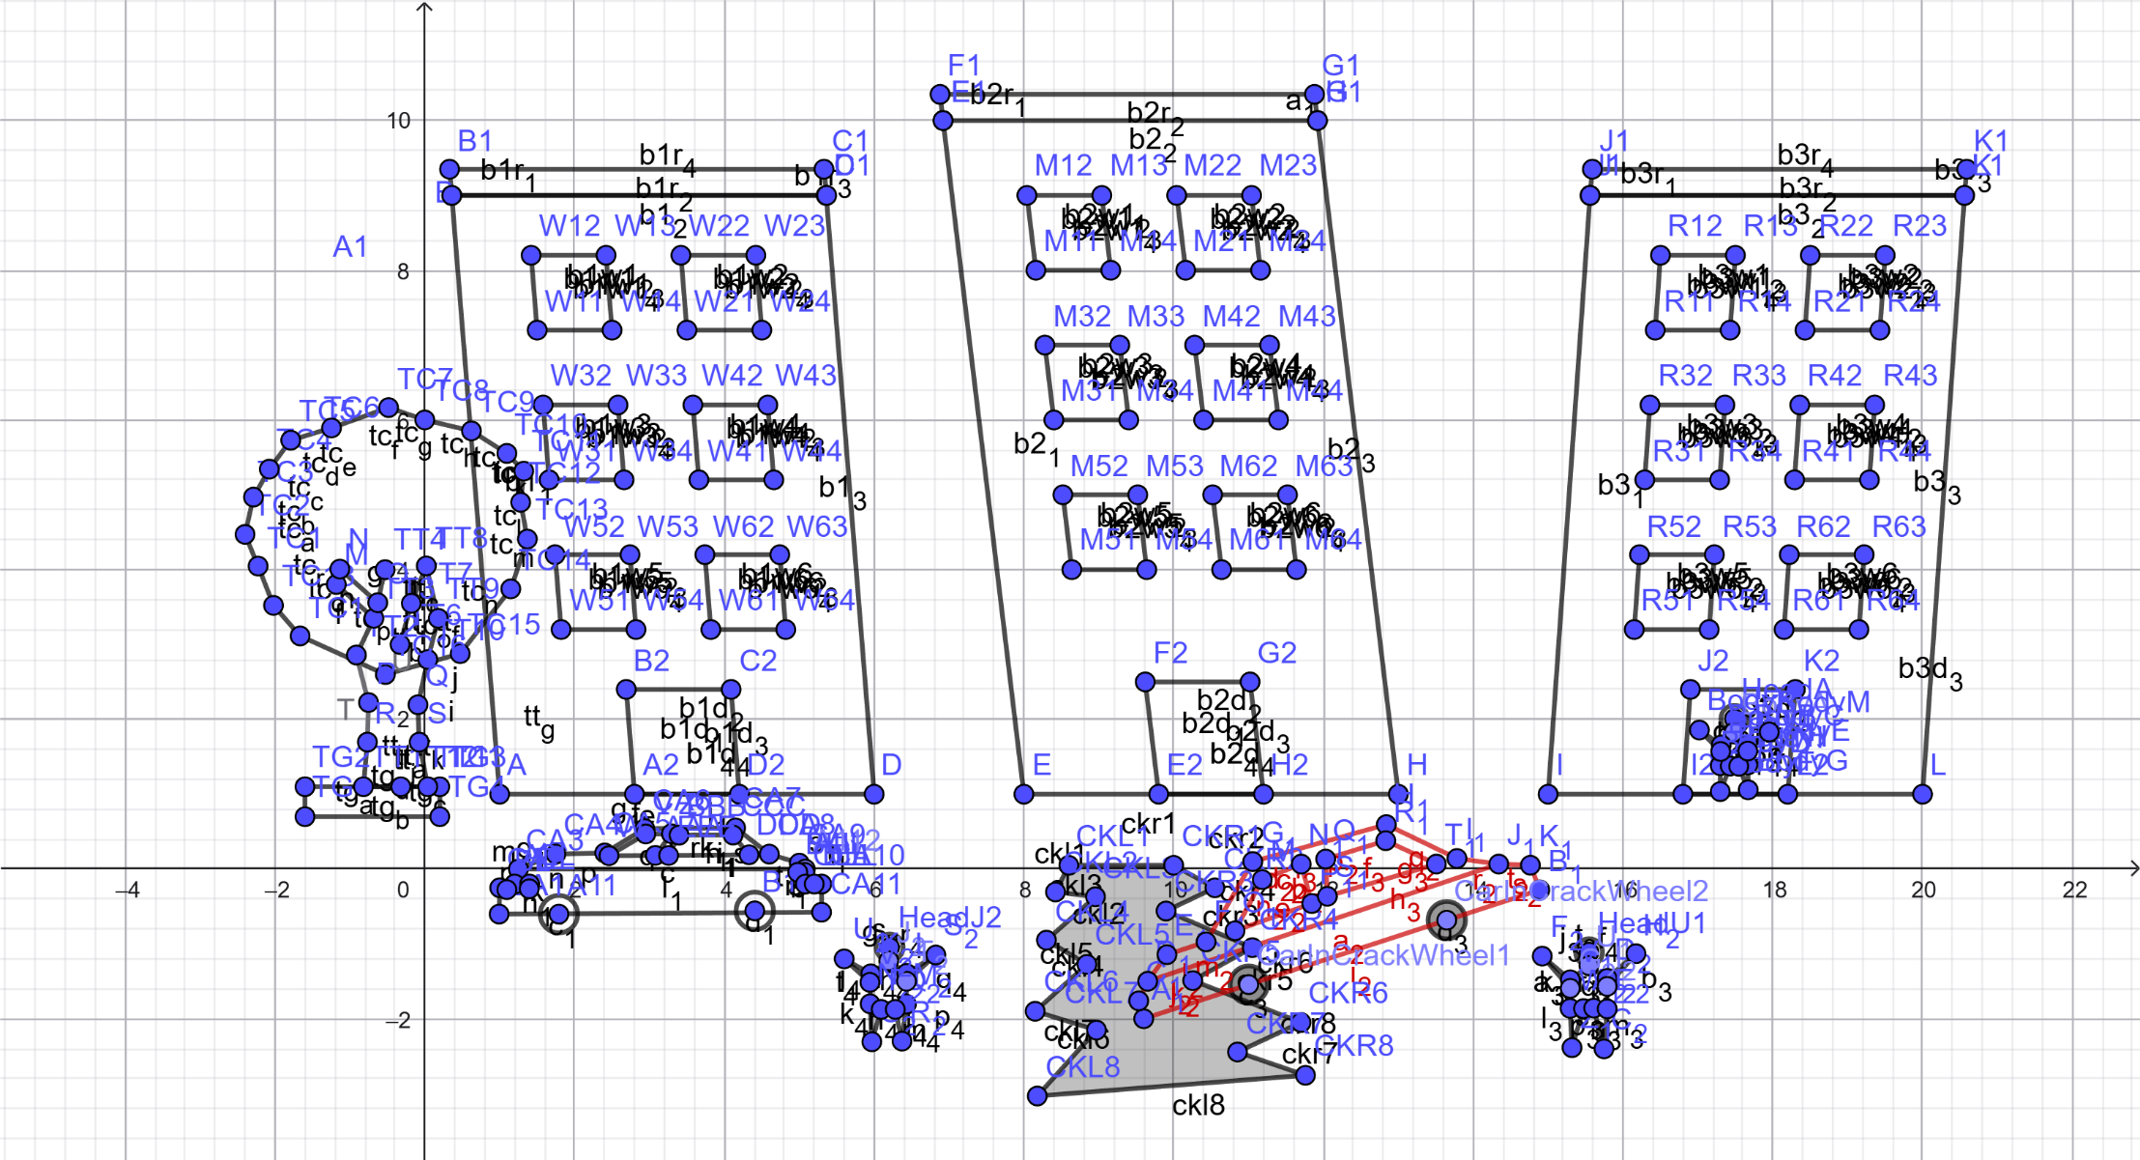
AIQUL ISLAM SAKIB (ID: 23-55255-3)

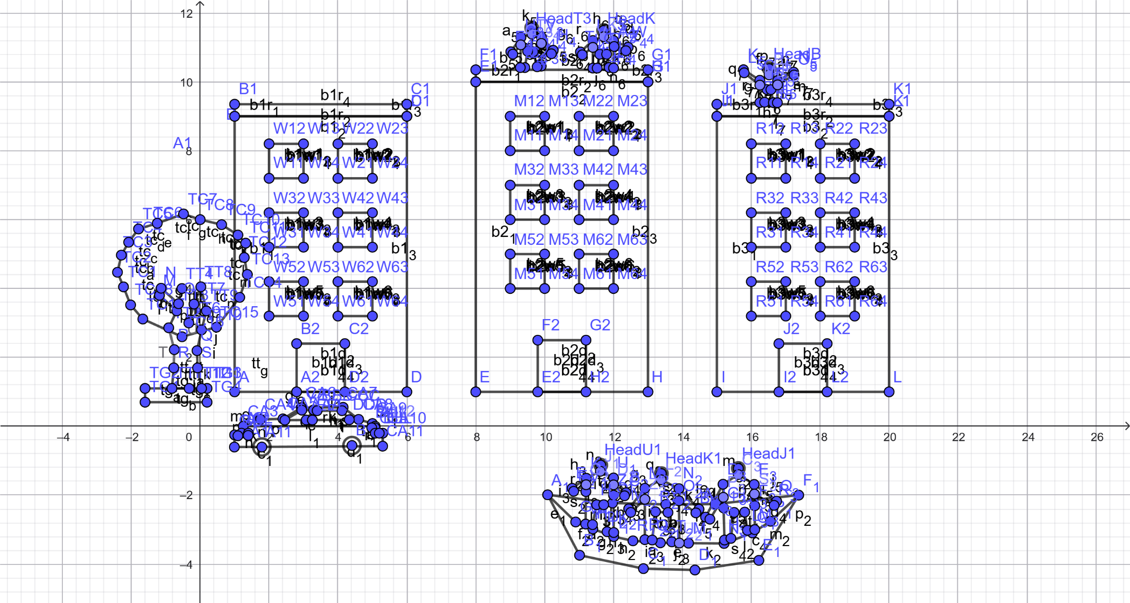
Fabiha Lamisa Tridha (ID: 23-54966-3)
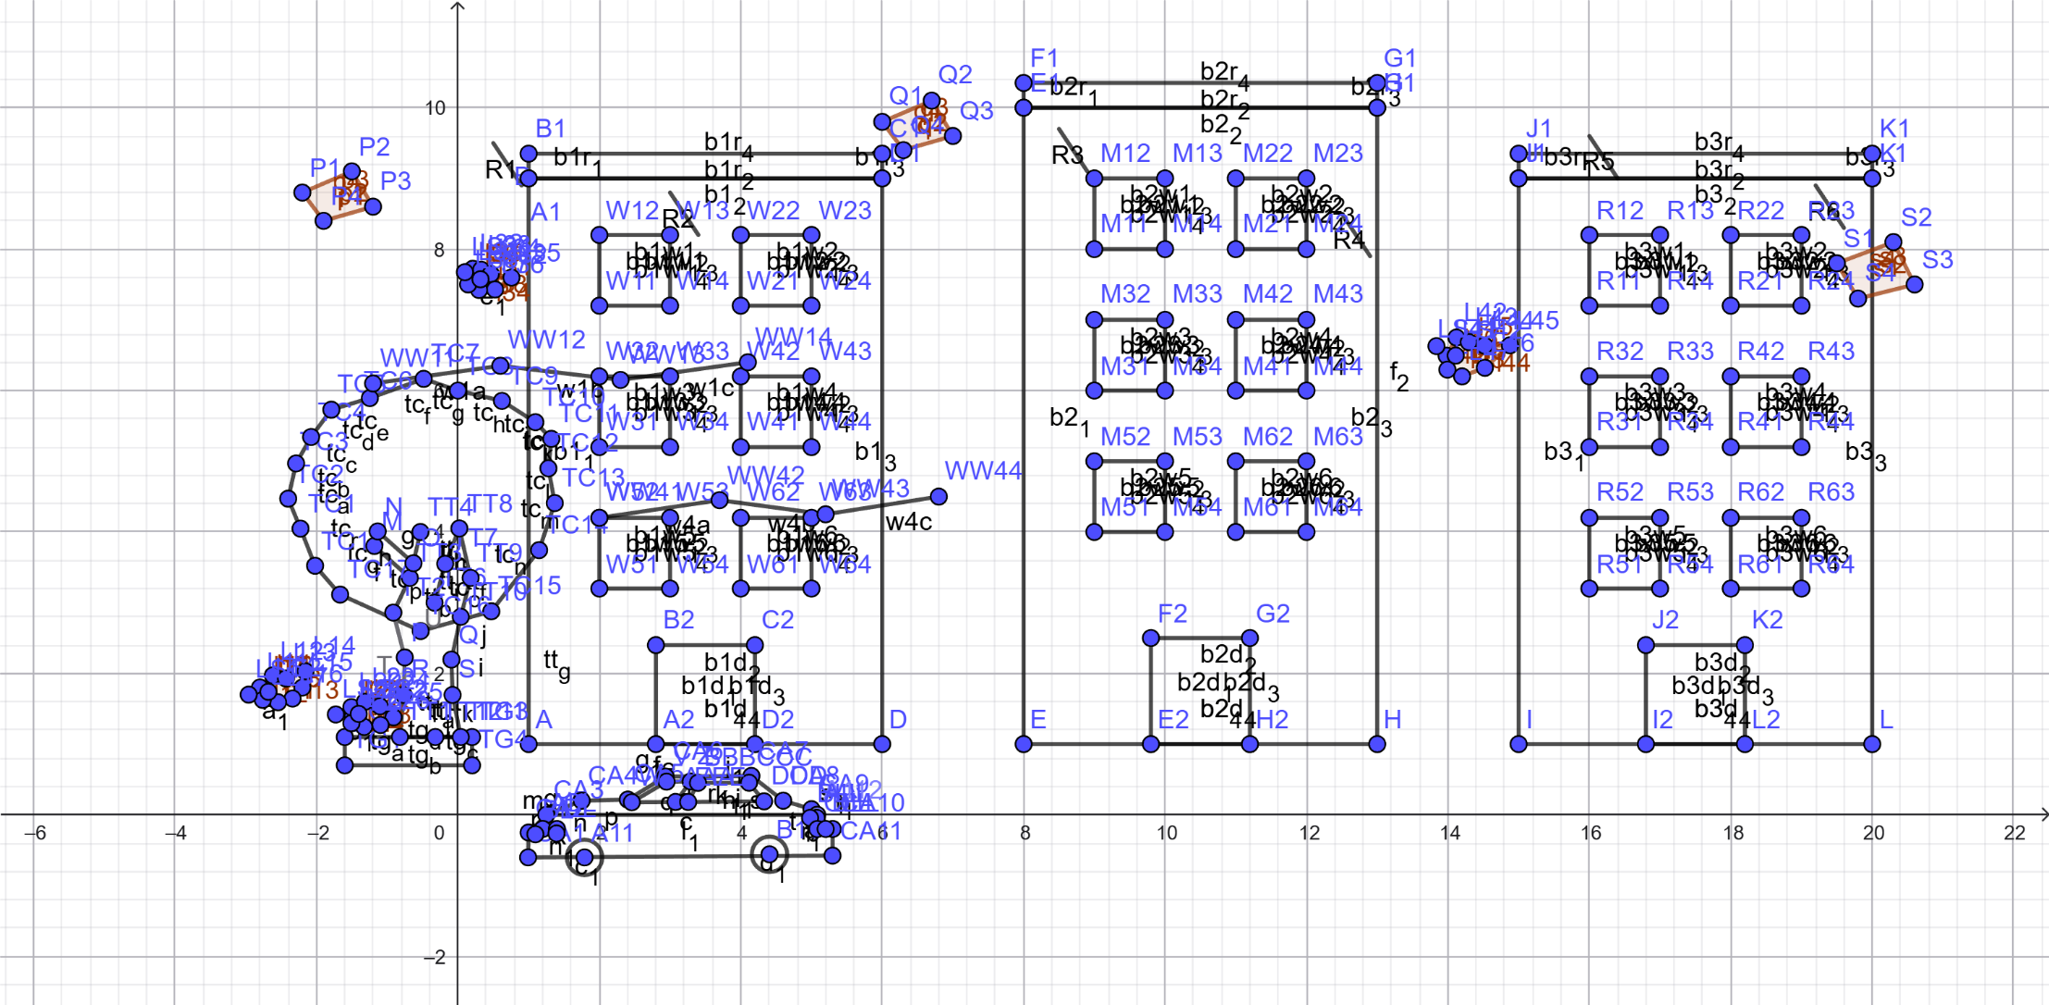
MD. NAFIS-UL HOQUE BONDHON (ID: 23-55212-3)

